PROJECT REPORT: SPACESHIP TITANIC SURVIVAL PREDICTION
Submitted by: Ishmal Nadeem
Roll No: SU92-BSAIM-F24-101
Submitted to: Sir Rasikh
Project Task: Kaggle Competition - Binary Classification

1. Introduction & Objective
The objective of this project is to predict which passengers were transported to an alternate dimension during the Spaceship Titanic's voyage. By analyzing personal data such as age, home planet, and luxury amenities used, we build a machine learning model to classify the outcome as either Transported (True) or Not Transported (False).

2. Requirements & Dependencies
This project requires the following Python libraries for data processing and model building:
- Pandas & NumPy: For data manipulation, handling missing values, and numerical operations.
- Scikit-Learn: To implement machine learning algorithms, scaling data, and evaluating performance.
- Matplotlib / Seaborn: Used for data visualization to understand the correlation between different features.

3. Feature Engineering & Preprocessing
Before training the model, the raw data requires significant cleaning. Based on the files train_preprocessed.csv and test_preprocessed.csv, the following steps were performed:
- Handling Missing Values: Null values in columns like HomePlanet, CryoSleep, and VIP were filled based on statistical modes or logical assumptions.
- Feature Extraction (Cabin Splitting): The Cabin ID (e.g., B/0/P) was split into Deck, Num, and Side. This is crucial because a passenger's location on the ship significantly affects their survival probability.
- Categorical Encoding: Text-based data (HomePlanet, Destination) was converted into numerical format so the mathematical model could interpret it.
- Feature Scaling: Using a StandardScaler, numerical features like Age and spending values (RoomService, Spa, etc.) were normalized to ensure that large numerical values do not bias the model's learning process.
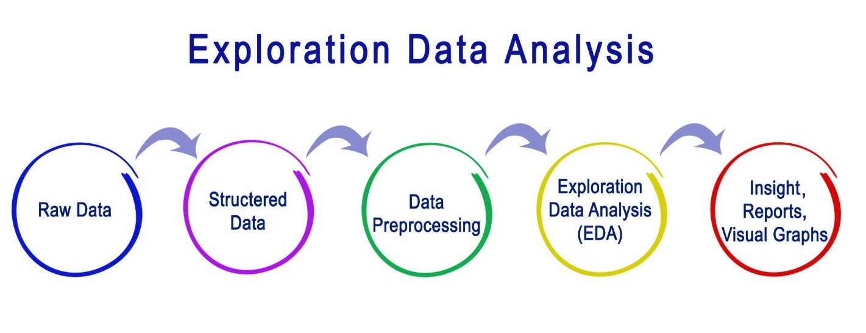
Getty Images

4. Model Logic & Implementation
The code in model.ipynb follows a standard machine learning pipeline:
- Data Loading: Importing the preprocessed training and testing datasets.
- Target Separation: Separating the Transported label from the features to train the model on patterns.
- Model Training: Training a classifier (such as Random Forest or Logistic Regression) to understand how variables like CryoSleep or Spa usage relate to the transport status.
- Prediction: Applying the trained model to the test_data to generate final predictions.

5. Justification (The "Why")
- Why use Preprocessing? Machine learning models cannot process raw strings or missing values. Preprocessing ensures the data is in a clean, mathematical format.
- Why Scale Features? Without scaling, a feature like "Spending" (which can be in thousands) would be treated as more important than "Age" (which is usually under 100), even if age is a better predictor.
- Why split the Cabin? The ship's structure (Decks and Sides) is a logical indicator of where the "anomaly" hit, making it a high-priority feature for accuracy.

6. Final Output
The final results are saved in submission.csv, containing the PassengerId and the predicted Transported status. This file is ready for submission to the Kaggle competition platform.

